

**JSS ACADEMY OF TECHNICAL EDUCATION, BANGALORE-560060**

**DEPARTMENT OF COMPUTER SCIENCE AND ENGINEERING**

**ACADEMIC YEAR: 2019-2020(ODD SEM)**

**SUBJECT: PROJECT WORK PHASE-I [15CSP78]**

**TOPIC: CROP YEILD PREDICTION USING MACHINE LEARNING**

**ALLOTED TEAM NUMBER:CSE19PT29**

|  |  |  |  |
| --- | --- | --- | --- |
| **NAME** | **USN** | **EMAIL** | **PHONE** |
| ANUSHA | 1JS16CS015 | anusha.1js16cs015@gmail.com | 7349489469 |
| BRUNDA. R | 1JS16CS030 | brundar.1js16cs030@gmail.com | 7026763418 |
| CHINNASANI HARSHITHA | 1JS16CS035 | charshitha.1js16cs035@gmail.com | 9491080671 |
| G. TEJASHWINI | 1JS16CS040 | gtejashwini.1js16cs040@gmail.com | 9980464765 |

**INTERNAL GUIDE : Mr.SharanaBasavana Gowda (Asst.Professor)**

**PROJECT TYPE : INHOUSE PROJECT**

**OBJECTIVE:**

To propose and implement a rule based system to predict the crop yield prediction from the

collection of data.

**ABSTRACT:**

India being an agriculture country, its economy predominantly depends on agriculture yield growth and agro-industry products. Data Mining is an emerging research field in crop yield analysis. Yield prediction is a very important issue in agricultural. Any farmer is interested in knowing how much yield he is about to expect. Analyze the various related attributes like location, pH value from which alkalinity of the soil is determined. Along with it, percentage of nutrients like Nitrogen(N), Phosphorous (P), and Potassium (K) Location is used along with the use of third-party applications like APIs for weather and temperature, type of soil, nutrient value of the soil in that region, amount of rainfall in the region, soil composition can be determined. All these attributes of data will be analyzed, train the data with various suitable machine learning algorithms for creating a model. The system comes with a model to be precise and accurate in predicting crop yield and deliver the end user with proper recommendations about required fertilizer ratio based on atmospheric and soil parameters of the land which enhance to increase the crop yield and increase farmer revenue.

# INTRODUCTION

INDIA is a highly populated country and randomly change in the climatic conditions need to secure the world food resources. Framers face serious problems in drought conditions. Type of soil plays a major role in the crop yield. Suggesting the use of fertilizers may help the farmers to make the best decision for their cropping situation. The number of studies Information and Communication Technology (ICT) can be applied for prediction of crop yield. By the use of Data Mining, we can also predict the crop yield. By fully analyze the previous data we can suggest the farmer for a better crop for the better yield.

# 

# EXISTING SYSTEM

The crop evapotranspiration is a function of both the weather and growth stage of the plant. This attribute is taken into consideration to get a good decision on the yield of the groups.They all collected the dataset with these attributes and send as input to the Bayesian network and classify into the two classes named true and false classes and compared with the observed classifications in the model with a confusion matrix and bring the accuracy. Finally, they concluded that crop yield prediction with Naïve Bayes and Bayesian network give high accuracy when compared to SMO classifier and forecasting the crop yield prediction in different climate and cropping scenarios will be beneficial.

# SYSTEM ARCHITECTURE:

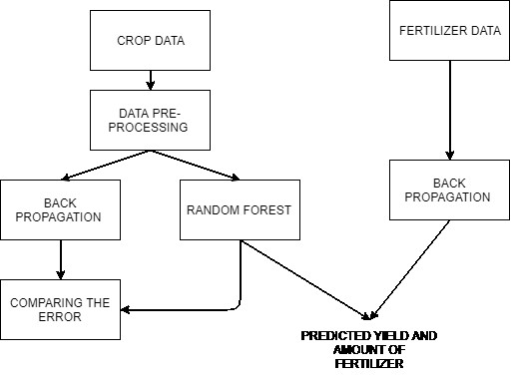

Fig. 1. Architecture diagram

# PROPOSED SYSTEM:

Prediction of the crop yield using the efficient algorithm and suggest how much quantity of fertilizer should be used to get the proper yield for the crop. All the main data used in the data set are initialized with the number to use in the algorithm it is like initializing all the details. In this metadata, we are going to initialize all the crop names with the numbers. This data makes us use the data easily in the algorithm. Hear the metadata of all the crops is given with a particular number. This number is not duplicated that is one number is given to one crop, the same number is not given to the other crop. This metadata consists of more than a hundred crops that grown all over India.

# METHODOLOGY:

* SVM algorithm
* Decision tree algorithm
* Image processing

# REQUIREMENTS:

**HARDWARE REQUIREMENTS:**

**System** : Pentium IV 2.4 GHz.

**Hard Disk**  : 250 GB.

**Ram**  : 2 GB

* *Any desktop / Laptop system with above configuration or higher level*

**SOFTWARE REQUIREMENTS:**

**Operating system** : Windows XP / 7

**Coding Language** : Java (Jdk 1.7) / Python

**Web Technology** : Servlet, JSP

**Web Server**  : TomCAT 7.0

**IDE**  : Eclipse Galileo

**Database** : My-SQL 5.0

**UGI for DB** : SQLyog

**JDBC Connection** : Type 4 - Native Drive

# BIBLIOGRAPHY

1. Niketa Gandhi et al ," Rice Crop Yield Forecasting of Tropical Wet and Dry Climatic Zone of India Using Data Mining Techniques" , IEEE International Conference on Advances in Computer Applications (ICACA) , 2016.
2. https://en.wikipedia.org/wiki/React_Native
3. https://interactio.io
4. <https://reactjs.org>